2025 STAMMA AGM AGENDA
22nd November, 2pm-4pm
St Anne’s Church, Community Hall, 55 Dean Street, London W1D 6DA
Zoom Link: https://bit.ly/STAMMA_agm2025
The zoom session will encompass the AGM only and will finish at 15:20pm. You will not be able to take part in the final session as we don’t have the equipment to enable you to be heard and for everyone to hear you.
From | To | Item | Lead
14:00 | 14:05 | Welcome & apologies | Roger Pim
14:05 | 14:10 | Minutes of the last meeting
14:10 | 14:25 | 2025 Impact | Jane Powell & Kirsten Howells
14:25 | 14:40 | Accounts & appointment of auditors | Nick Pearce
14:40 | 14:55 | Trustee Elections | Paul Fix
14:55 | 15:10 | Resolutions to the changes of Articles | Roger Pim
15:10 | 15:20 | AOB and end of the formal session
15:20 | 15:30 | Tea break
15:30 | 16:00 | Campaign discussion | Jane Powell

GETTING THERE
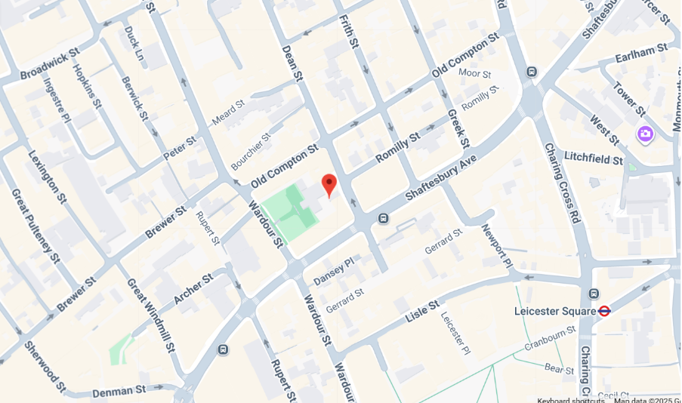
St Anne’s Church, Community Hall, 55 Dean Street, London W1D 6DA
Bus: Routes 14, 19, 24, 29, 38, 176 stop nearby.
Underground: Nearest stations: Leicester Sq, Piccadilly Circus, and Tottenham Court Road.
Rail: Charing Cross Station is a 10-minute walk.
Parking: Limited street parking nearby. Bay parking (max 4 hours) opposite the church. Multi-storey car parks in Chinatown and Brewer Street.

